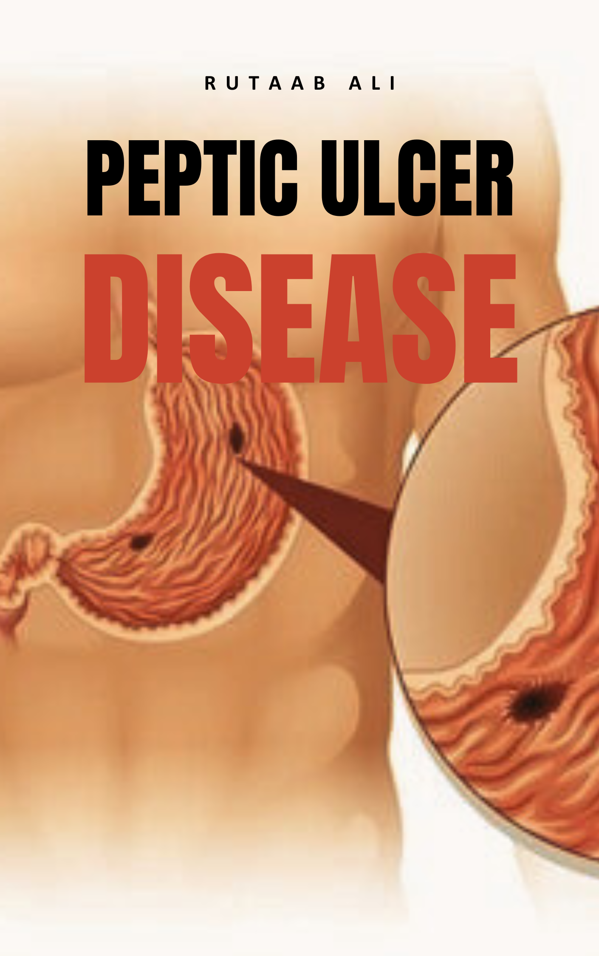

Peptic Ulcer Disease (PUD)
Peptic Ulcer Disease (PUD) is a condition characterized by the formation of open sores or "excavations" in the lining of the digestive tract. It is essentially a break in the lining (lesion) of the stomach, first part of the small intestine (duodenum), or occasionally the lower esophagus. This damage occurs when the gastrointestinal mucosa is exposed to the aggressive action of acid-peptic juices, leading to a local defect or excavation produced by the shedding of inflamed necrotic tissue.
Ulcers in the stomach are called gastric ulcers, while those in the first part of the intestines are known as duodenal ulcers. The most common sites for ulcers are the first part of the duodenum and the lesser curve of the stomach. Duodenal ulcers are notably more common, accounting for almost 80% of peptic ulcers and occurring four times more frequently in the proximal duodenum than in the stomach. Stomach ulcers make up almost 20% of cases.
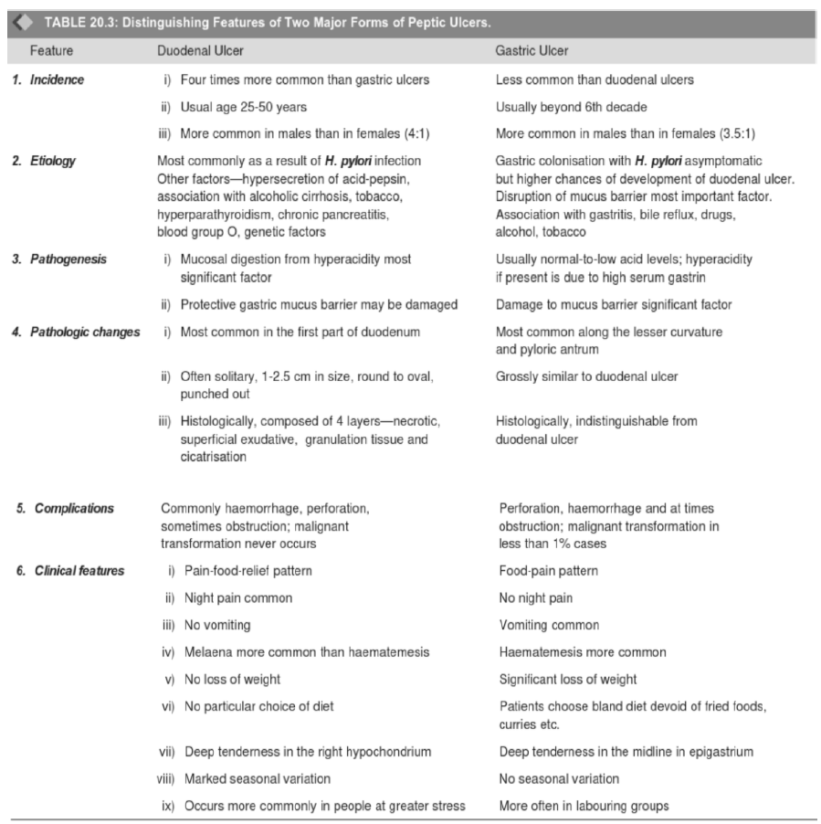

Epidemiology and Prevalence
The lifetime prevalence of PUD in the general population is estimated to be around 5–10%, with an annual incidence of 0.1–0.3%. Up to 10% of the population is estimated to develop an ulcer. There has been a sharp reduction in PUD cases in developed countries due to new curative therapies. The lifetime risk for developing an ulcer is approximately 10% for males and 4% for females. PUD leads to the treatment of over 3 million individuals, 190,000 hospitalizations, and approximately 5,000 deaths annually in the United States.

Main Causes of Peptic Ulcer Disease
Historically, lifestyle factors like stress and diet were thought to be the main culprits, but current understanding points to two primary causes:

Helicobacter pylori (H. pylori) Infection:
  - While common, "only 5% to 10% of H. pylori–infected individuals develop ulcers," suggesting host factors and bacterial strain variation also play a role
  - Most ulcers are caused by an infection from bacteria. This bacterium, Helicobacter pylori, is a major cause of peptic ulcers, associated with more than 70% of PUD cases.
  - H. pylori is a small, spiral, gram-negative bacillus that inhabits the mucous layer overlying gastric epithelial cells. It inflames the protective lining, leading to increased stomach acid production and damage.
  - Many people acquire H. pylori during childhood, though adults can also get it, often living in the body for years before symptoms appear. Most people with H. pylori never develop ulcers. Doctors are not sure why only some individuals develop ulcers after infection.
  - You can get H. pylori from food, water, or utensils, and it's more common in areas lacking clean water or good sewage systems. Contact with saliva or other body fluids of infected people can also transmit the bacteria.
  - Mechanism of Damage: H. pylori secretes urease, which generates ammonia, and protease, which breaks down glycoprotein in the gastric mucus. It also expresses adhesins (like BabA or OipA) that facilitate attachment to gastric epithelium. Bacterial lipopolysaccharide attracts inflammatory cells to the mucosa. The bacteria's actions lead to damage of the protective mucosal layer, exposing epithelial cells to acid-peptic digestion, and cause inflammation of the gastric mucosa, where ulcers then occur.
  - Damaging factors of H. pylori include:
    - Vacuolating cytotoxin A (VacA), which damages epithelial cells, disrupts tight junctions, and causes apoptosis.
    - Cytotoxin associated gene CagA, which can also cause inflammation and is potentially a carcinogen.
    - Enzymes such as urease, phospholipases, and catalases.

Nonsteroidal Anti-inflammatory Drugs (NSAIDs):
  - NSAIDs are the second biggest cause of ulcers. Common over-the-counter pain relievers like aspirin, ibuprofen, and naproxen can cause ulcers.
  - NSAIDs inhibit COX enzymes, specifically blocking cyclooxygenase (COX)-dependent synthesis of prostaglandins. Prostaglandins are crucial for mucus and bicarbonate secretion, mucosal blood flow, and epithelial restitution, which are essential defense mechanisms of the gastrointestinal lining.
  - In the United States, NSAID use is becoming the most common cause of gastric ulcers as H. pylori infection rates decline and low-dose aspirin use increases in the aging population. NSAID-related gastrointestinal side-effects lead to over 16,000 deaths and 100,000 hospitalizations annually in the US.

Contributing Factors
- Acid Hypersecretion: Can be caused by H. pylori, parietal cell hyperplasia, or excessive secretory responses.
- Zollinger-Ellison syndrome: A rare condition causing uncontrolled release of gastrin by a tumor, leading to massive acid production.
- Smoking: A risk factor for development, maintenance, and recurrence of PUD. Tobacco use is associated with increased risk. It can inhibit pancreatic bicarbonate secretion, reduce mucosal blood flow, inhibit mucosal prostaglandin production, and interfere with the stomach's protective lining, making it more susceptible to ulcers.
- Alcohol Intake: Excessive use can irritate and erode the mucous lining, causing inflammation and bleeding (gastritis). Toxins and irritants from alcohol are hard on the digestive tract. Excessive alcohol consumption is widely considered to increase the risk of developing an ulcer.
- Stress: While there is no clear evidence that the stress of modern life directly causes ulcers, severe physiological stress (e.g., from life-threatening illness or injury) is mentioned as an uncommon cause. Stress can cause decreased blood flow to the mucosa, leading to ischemia and subsequent destruction of the mucosal lining, and reduce bicarbonate concentration in mucous secretion.
- Family History of PUD.
- High-dose corticosteroids: Can suppress prostaglandin synthesis and impair healing.
- Associated medical conditions: More frequent in individuals with alcoholic cirrhosis, chronic obstructive pulmonary disease, chronic renal failure, and hyperparathyroidism (the latter two due to hypercalcemia stimulating gastrin production).
- Chemotherapy, radiation therapy, other infections, ischemia, Crohn's disease, and stomach cancer are also mentioned as uncommon causes.

Defensive Ingredients against PUD
The body has natural defenses, including:
- Bicarbonate
- Mucus layer
- Prostaglandins (found in high concentration in gastric mucosa and gastric juice; inhibit acid secretion, stimulate mucus and bicarbonate secretion, alter mucosal blood flow, and provide protection against mucosal damage)
- Mucosal blood flow
- Epithelial renewal

Signs and Symptoms
Many people with PUD (up to 70%) may experience no symptoms. When symptoms do occur, they can vary:
- Pain or discomfort in the upper abdomen. Often described as a dull or burning pain between the breastbone and navel, or a "burning or gnawing" sensation in the central upper abdominal pain (epigastric pain).
  - Pain often occurs 1 to 3 hours after meals during the day, is worse at night, and is relieved by alkali or food.
  - For duodenal ulcers, pain may feel better shortly after a meal but worsen 2-3 hours later, and can awaken individuals at night.
  - Stomach ulcer pain often feels worse shortly after a meal (within 30 minutes).
- Feeling full and bloated after eating; unable to drink as much fluid.
- Nausea and Vomiting.
- Significant weight loss and loss of appetite.
- Burping or belching.

Complications of PUD
Untreated ulcers can lead to serious, potentially life-threatening complications that require emergency medical attention:
- Gastrointestinal bleeding: Occurs in one-third of patients. Vomit may look bloody or resemble "coffee grounds". Stools can be bloody or dark/black, tarry. Other signs include dizziness, faintness, pallor, and rapid heart rate. Bleeding can range from a small trickle to a serious, life-threatening bleed.
- Cancer: Helicobacter pylori is an etiological factor, making it 3-6 times more likely to develop stomach cancer. The isolation of H. pylori radically changed the perception of its involvement in gastric adenocarcinomas.
- Perforation (hole): A sharp pain in your stomach that doesn't go away. This is a sudden, sharp and severe abdominal pain, potentially with abdominal swelling, tenderness, fever, and chills. This occurs when the ulcer goes through the wall of the duodenum, causing food and acid to leak into the belly.
- Obstruction/Narrowing: Occurs when ulcers in certain areas cause swelling and scarring, blocking food passage. Symptoms include abdominal bloating, swelling and pain, nausea, vomiting, loss of appetite, weight loss, and constipation.

Diagnosis of PUD
Diagnosis typically involves a combination of patient history, physical examination, and specific tests:

Tests for H. pylori infection:
  - Stool antigen test (detects bacteria in the stool).
  - Urea breath test (involves swallowing a urea pill; H. pylori breaks it down, producing detectable carbon dioxide in breath).
  - Blood tests (check for antibodies against H. pylori, specifically levels of IgG and IgA ELISA test).

Visualizing the ulcer and biopsy:
  - Endoscopic diagnosis / Gastroscopy / Upper endoscopy (EGD): Involves inserting a long, flexible tube (endoscope) with a camera down the throat to examine the esophagus, stomach, and duodenum. A small tissue sample (biopsy) can be taken to test for H. pylori or other abnormalities. This allows direct visualization and immediate treatment of bleeding if necessary.
- Upper GI (gastrointestinal) series or barium swallow: An imaging test where the patient swallows a metallic fluid (barium) to coat the organs, making them visible on X-ray.
- CT scan (computed tomography scan): Can detect larger ulcers.

Treatment and Management
Treatment aims to eliminate the underlying cause, reduce stomach acid, and protect the gastrointestinal lining. Most peptic ulcers heal with medication within a few weeks, often about two months.

Medications:
  - Antibiotics: If H. pylori is the cause, "triple therapy" is common, involving two antibiotics and a proton pump inhibitor (PPI). Common antibiotics include Doxycycline, Metronidazole, Clarithromycin, and Amoxicillin.
    - Triple Therapy Regimens:
      - Bismuth subsalicylate (2 tablets qid) + Metronidazole (250 mg qid) + Tetracycline (500 mg qid).
      - Ranitidine bismuth citrate (400 mg bid) + Tetracycline (500 mg bid) + Clarithromycin or Metronidazole (500 mg bid).
      - Omeprazole (20 mg bid) or Lansoprazole (30 mg bid) + Clarithromycin (250 or 500 mg bid) + Metronidazole (500 mg bid) or Amoxicillin (1 g bid).
    - Quadruple Therapy Regimen: Omeprazole (20 mg daily) or Lansoprazole (30 mg daily) + Bismuth subsalicylate (2 tablets qid) + Metronidazole (250 mg qid) + Tetracycline (500 mg qid).
  - Proton Pump Inhibitors (PPIs): Reduce the acid made by your stomach and help coat and protect the lining. Examples include Omeprazole, Lansoprazole, Rabeprazole, Pantoprazole, and Esomeprazole.
  - H2-blockers (Histamine receptor blockers): Reduce stomach acid production by blocking histamine. Examples: Ranitidine, Famotidine, Nizatidine, Cimetidine.
  - Mucosal Protective Agents / Cytoprotective agents: Help coat and protect the lining for healing. Examples: Sucralfate, Misoprostol, Bismuth subsalicylate (BSS).
  - Antacids: Quickly weaken or neutralize stomach acid to ease symptoms, but cannot cure the ulcer.
  - NSAID alternatives: If NSAIDs are the cause, discontinuing them is advised, and Acetaminophen is suggested as an alternative pain reliever.

Lifestyle Changes:
  - Dietary adjustments: Avoiding "triggering foods" like coffee, fatty foods, spicy foods, and acidic foods (e.g., tomato). Eating smaller meals and having evening meals a few hours before bedtime are also recommended.
  - Quitting smoking: Smoking can prevent ulcers from healing and is linked to recurrence.
  - Limiting alcohol and caffeine: Can worsen symptoms.
  - Weight loss: If living with obesity.

Medical Procedures/Surgery:
  - Medications heal most ulcers.
  - Surgery is typically reserved primarily for treatment of ulcers with uncontrollable bleeding or perforation.
  - During endoscopy, bleeding ulcers can be treated by cauterizing or injecting medication into the wound. Perforations can be repaired with stitches.
  - For obstructions, interventions to reopen the channel (e.g., suctioning or, rarely, surgery like pyloroplasty or vagotomy) may be needed.

Prognosis and Prevention
- Prognosis: If H. pylori infection is eradicated, most ulcers do not recur. However, chronic conditions like Zollinger-Ellison syndrome may require lifelong medication. Follow-up tests are important to ensure healing and infection clearance.
- Prevention:
  - Test for and eradicate H. pylori: Especially if infected, treating it proactively can prevent PUD.
  - Use NSAIDs only as directed: Avoid overuse and discuss alternatives with a healthcare provider, especially with a history of PUD. If NSAIDs must be taken, consider taking them with another medication to protect the lining.
  - Practice good hygiene: Can help prevent H. pylori infection.

